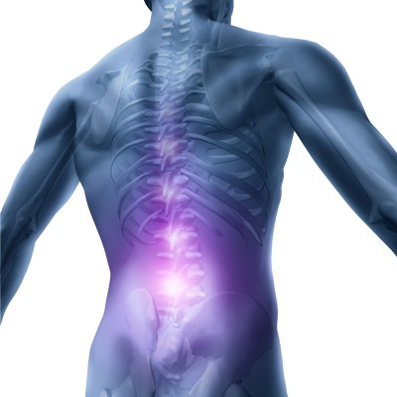

**Back Problems- Case Studies**

**BACK: CONSTANT LOWER BACK ACHE - Woman, 40s, 1 treatment**  
"I am a Consultant Paediatrician and, while my training has been in orthodox medicine, I have long been aware of the limitations of modern Western medicine in addressing basic issues relating to the promotion of health and well being and prevention of disturbed function of the human organism. Over the last few years I have explored the preventative and therapeutic benefits of a number of practices complementary to medicine and have trained in several therapies. I was introduced to The Bowen Technique during a joint consultation with a kinesiologist who had trained in it. I had been experiencing a constant ache in my lower back for some time and therefore became the fortunate recipient of a Bowen treatment. To my amazement, I experienced immediate relief and this happy state held over time. I was so impressed that I enrolled in the training course and now also use The Bowen Technique on a number of conditions. If only The Bowen Technique could fit the criteria for acceptance in the current climate of Evidence Based Medicine, the benefits to individuals and the savings for the NHS would be enormous."

**BACK PAIN - SCIATICA - Man, aged 40, 1 treatment**  
P. was unable to put weight on his right foot and the therapist paid a home visit. He was in severe pain and had been all day, from the buttock right down the leg. He was extremely tense and tight. The therapist gave him one treatment and was able to observe his body relaxing during the 40 minute session.. He was virtually pain free when he got up and was walking normally. Two years later, the therapist reports that the problem has not returned.

**BACK PAIN & HIGH BLOOD PRESSURE - Woman, aged 54, 3 treatments**  
Bowen Technique practitioner Annie Sewart, who is also a physiotherapist, treated Mrs C who came with a history of back pain which included a particularly bad episode two years previously. In addition, she also looks after her disabled mother at home. Typically, her back pain would also travel down to her left knee. An x-ray revealed that 3 lumbar vertebra had reduced cartilage. Two weeks before she came for Bowen treatment, Mrs C's back "went" during a skiing holiday when she stood up from a sitting position! When she came for the first treatment, Annie noted that Mrs C also had high blood pressure. During the first treatment, Mrs C felt very woozy and was hot and flushed after, so remained lying down for a while. She said that her back was then painful for two days following the treatment but that something "snapped" as she was walking and the pain was gone. At her third treatment, she reported feeling a bit stiff, still, but had been playing tennis. In addition, her blood pressure was normal for the first time in two years. One week later, she was feeling fine and has not needed further treatment.